Deliverables - R166.B.5.C.3.1 Conventional Modification
End Fitting

Project Ref. | R166
Document No. | R166.B.5.C.3.1
Revision | Rev 0
Date | 24 May 2017
Author | David Finch
Prepared For | GE
GE Document Classification and Security * | GE Confidential

* Public – Non-sensitive, published/public domain information, GE Internal – Company information not for disclosure to the public or to external parties but generally available to all employees and authorised non-employees, GE Confidential – Information that is sensitive or confidential within the Company and intended for business use only by those with a need-to-know, GE Restricted – Information that is extremely sensitive or private, of highest value to the Company, and intended for use by named individuals only

Deliverables - R166.B.5.C.3.1 Conventional Modification
Document No | R166.B.5.C.3.1 |  |  | Rev |  | Rev 0 |  | Project |  | R166
Document Classification and Security |  |  |  |  | GE Confidential
The purpose of this scope of work is to ensure that a standard end fitting can be utilised for use with a hybrid composite flexible pipe. When complete this package of work should ensure that the pipe structure information generated by Pipe Systems Design will allow the End Fitting Design Engineer to achieve an optimum design that satisfies stress, material, design and service requirements.
Keywords
Date | Rev |  | Originated |  |  |  | Reviewed |  | Approved
25/05/2017 | 00 |  | D Finch |  |  |  | V Jha |  | N Dodds
Click here to enter a date. | 01
Rev | Description
00 | Draft issued for internal review
01 | Initial issue
02
Internal Distribution |  | Wellstream Library
External Distribution |  | GE
* Public – Non-sensitive, published/public domain information, GE Internal – Company information not for disclosure to the public or to external parties but generally available to all employees and authorised non-employees, GE Confidential – Information that is sensitive or confidential within the Company and intended for business use only by those with a need-to-know, GE Restricted – Information that is extremely sensitive or private, of highest value to the Company, and intended for use by named individuals only

Deliverables R166.B.5.C.3.1 Conventional Modification

Table of Contents
1 Introduction 3
2 Purpose 3
3 Deliverables 4
3.1 Preliminary design review 4
3.2 Final design review 4
3.3 MRP/BOM readiness 4
3.4 Design guidelines 4

Introduction
This work package covers the design, analysis and testing to adapt and enable a standard end fitting assembly (Figure 1-1) suitable for use with a hybrid composite flexible pipe. This scope of work will focus on the preparation of a composite pipe prior to end fitting, the assembly and location of parts with focus placed on the design and swaging of a standard seal ring.

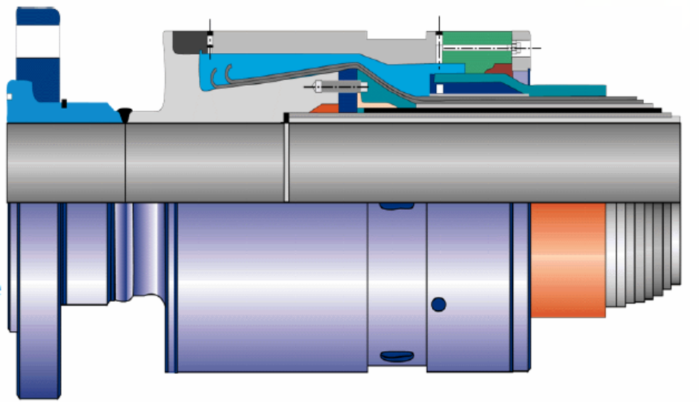
Standard end fitting

Purpose
The purpose of this scope of work is to ensure that a standard end fitting can be utilised for use with a hybrid composite flexible pipe. When complete this package of work should ensure that the pipe structure information generated by Pipe Systems Design will allow the End Fitting Design Engineer to achieve an optimum design that satisfies stress, material, design and service requirement

Deliverables
The service provider shall deliver the following deliverables:

Preliminary design review (PDR)
During the PDR, a technical assessment will be established of the current end fitting design and its operational effectiveness. This review will assess each of the major components within the end fitting design and establish if these can be configured for use on a hybrid composite flexible pipe. Particular attention will be placed on the design and suitability of the following:
- Metallic tensile wire / end fitting integration
- Leverage existing manufacturing processes
- Metallic armour wires terminated in end fitting using existing methods
- Barrier seal rings identical to existing product
Once complete the review should indicate if the design satisfies the functional and non-functional requirements such as performance, cost, producibility, health and safety along with environmental concerns.

Critical design review (CDR)
During the CDR a multi-disciplined detailed technical review of the end fitting design will be conducted to ensure that the design can proceed into manufacture, demonstration and test having met the performance criteria set out in the pipe system design. The CDR will determine the following
- End fitting design satisfies cost requirements
- Establish compatibility of existing components with new parts
- Identify areas of risk
- Determine the acceptability of the design against performance requirements.

Performance readiness review (PRR)
The PRR will assess if the end fitting design is ready for production and formal release to manufacturing. It will assess if all the performance and production requirements have been met including:
- The manufacturing readiness process
- Quality management system
- Production planning
- System requirements compliance
- Inventory management
- Supplier management

Design guidelines
The Wellstream design guidelines will be revised to reflect the new criteria for design, manufacture and installation of an end fitting for a hybrid composite flexible pipe.

